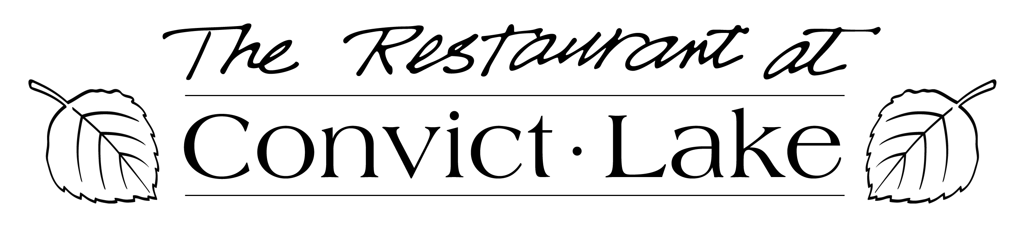

Thanksgiving Dinner 2018

Appetizers

**Burgundy Escargot**

Served en croute with herbs de Provence-garlic butter…$13

**Clay Pot Roasted Garlic**

Extra virgin olive oil, balsamic syrup and soft grilled crostini’s...$9

**Baked Brie En Croute**

Apricot coulis, fresh and dried fruit, toasted almonds and table crackers …$16

**Crab and Argentinian Shrimp Cake**

Served on baby arugula, with grapefruit and orange Supremes and a jalapeno basil aioli…$15

$49.95 per person, $24.95 for children 11 & under

Thank you for joining us this evening. Please choose one item from each below. Offered above are additional appetizers.

**First Course**

**Baby Field Greens & Applewood Smoked Bacon**

Pickled cucumber-red cabbage relish, clover honey-apple cider vinaigrette

Or

**Convict Caesar**

Romaine hearts and herbed croutons half order Caesar

Or

**Soup Du Jour**

**Entrée Course**

Served with haricot verts, ginger sweet potato puree,

Sausage - Fuji apple - vanilla bean stuffing and mashed potatoes

**Herb Roasted Free-Range Turkey**

Served with gravy and homemade cranberry sauce

Or

**Prime Rib Au Jus**

Served with burgundy glace de veau and horseradish chive cream sauce

Or

**Blackened Fresh Scottish Salmon**

Pans seared and finished with a mango beurre blanc

**Dessert Course**

**Traditional Pumpkin Pie ~ Vanilla Bean Crème Brule**

**Ice Cream of the Day ~ Cheese Cake Du Jour**

An 18% gratuity will be added to parties of Six or more.